EIT RawMaterials

Go-to-market strategy for upscaling projects
Process and guidance
March 2022
1. Background information
Upscaling projects are innovation projects based on validated technologies (TRL5) that need additional steps for demonstration or implementation and must aim at market introduction and/or a commercial use within three years after the end of the project. The project team in an upscaling projects needs to have a clear focus on customer needs, value proposition, market analysis, IP strategy, competitor landscape, as well as a pathway for implementation and commercialisation. All these factors must be included in a Go-To-Market (GTM) Strategy and need to be addressed in the project proposal stage, updated during the project’s duration and pursued after the funding period. This document describes the purpose, process and indicative content of the GTM Strategy. At the end of the document you will find a GTM Strategy template.
Starting from KAVA call 5 for Upscaling projects, the EIT RawMaterials has required the inclusion of a Work Package (WP) for GTM Strategy running over the whole project duration. This WP is expected to produce a business model and a business plan for commercialisation in order to fill the gap from the end of the project to market introduction. The main objective of the WP is to secure the project team’s capacity and availability to implement, disseminate and commercialise the project’s results and learnings.
2. Timeline and reviewing process
The GTM activities should be revised every year, and clear business milestones should be defined. Activities carried out every year in the GTM WP should validate the identified project milestones.
Initial discussion: The preliminary GTM Strategy is to be discussed with the assigned project officer (PO) during the first project review/kick-off meeting on year one (no document submission is required at this stage). Based on this preliminary discussion, project coordinators, together with the project team will start developing the first GTM Strategy report.
GTM Strategy submission: The report is a mandatory project deliverable and it is to be submitted annually by the project coordinator together with the KAVA content reporting in mid-March, starting from the second year of the project. The last report will be submitted together with the final project report (mid-March following the last funding year of the project).
GTM Strategy review: The submitted GTM strategy will be reviewed by the PO before or during the first annual project review (PR1) or project kick-off meeting to be held in H1, where the strategy will be discussed (Figure 1). EIT RawMaterials Senior Advisors and other senior staff may support project officers in reviewing the submitted documentation. Should the GTM Strategy contain critical findings, which could put the project in jeopardy, the project team may be requested to deliver a remediation plan before the second project review in the fall of the same year.
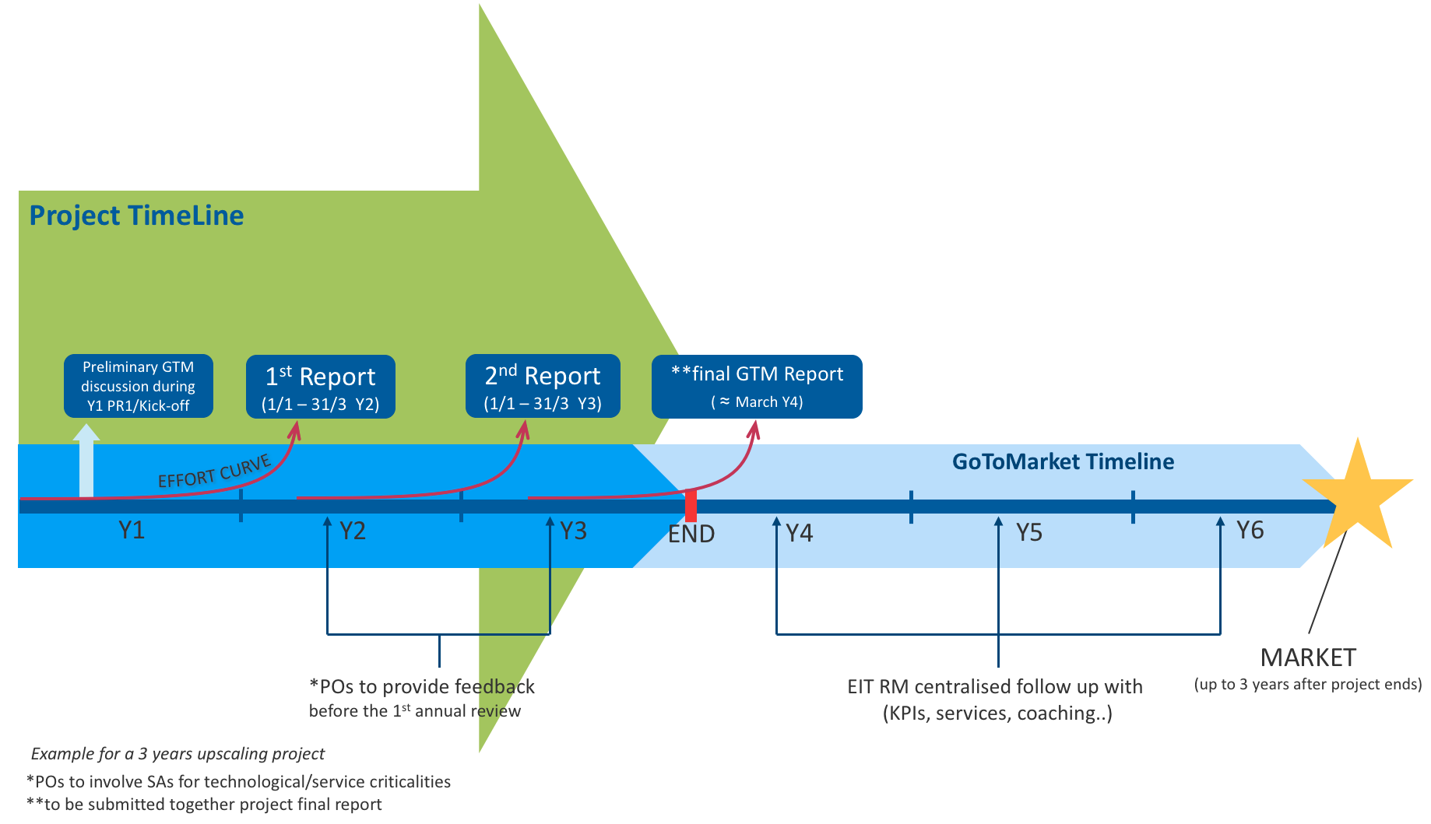

Figure 1. Conceptual timeline of the Go-to-market WP for Upscaling projects.

3. Content of Go-to Market WP
The content of the GTM WP should be individually designed for each project, depending on the specific needs, and should consist of selected processes and activities that will support the project consortium to build a feasible roadmap for the implementation or commercialization of the results of the project after its end. The project consortium should identify the different roles and interest of the project partners, to secure GTM strategy for the expected outcomes and results of the project.
Activities need to be planned to reach the milestones set in the GTM process. The extent of the yearly reports expected from the progression of the GTM WP will increase every year and will be eventually delivered as a final GTM strategy at the end of the project. The report will include a clear roadmap for the implementation and commercialisation plan. Activities should be designed to support the project development and key impact factors should be identified to address:
- Technology
- Target markets (size, structure, growth potential, segmentation, etc.)
- User needs and targeted applications and customer value proposition
- Entrepreneurship (new spinoffs / start-ups)
- External context (technical, regulatory, social, environmental, political, etc.)
- Competition and competitive advantage
- Value chain with stakeholders, partners, customer and distribution strategy
- Risk assessment
- Intellectual property rights strategy
- Business Model
- Investment required, Financial plan and model
- Implementation and commercialisation plan

A GTM template has been created as a starting point for each project to adjust to their needs. Furthermore, the level of maturity of the different sections of the GTM can differ from project to project and should evolve in the different yearly releases together with the project progression. The GTM document should not exceed the overall the length of ten pages, excluding additional information that can be attached as Annexes.

TEMPLATE FOR GO-TO-MARKET SRATEGY

- EXECUTIVE BUSINESS SUMMARY
The executive summary should be a clear and concise description of the project’s key elements: “What, Why and How”. This text may be used as part of the Business Plan, or for presentations and other materials, and should therefore be formulated as a business pitch.
- VALUE PROPOSITION
The objective of this section is to provide a clear description of the real market demand that the solution is addressing, the customer value and advantages achieved by using the solution, the competitive advantage with respect to the state of the art, and the IP status. It should be written in a short and concise way, referring to both qualitative and quantitative targets. The value proposition should be highlighted through the output of a customer validation (interviews, meetings, demonstration/test at customer site), the analysis of a potential use case with quantified benefits to the user, or evidence of legislative or regulatory requirements.

Customer needs and demand
Explain the customer/user needs or demand that the solution addresses (and justify how these needs have been investigated and validated). Indicate the regulatory/legislative context and the related needs of new solutions.
Describe the proposed solution (product/service/process), its specific characteristics and how it will contribute to solving the problem (in terms of cost, performance, efficiency, safety, environmental impact, lifetime, etc.) for a potential customer. Indicate who is your target customer and the benefits and value they will get from the application of the solution through the description of a use case.
Provide simple statements addressing the following:
- What are the main challenges solved by this solution?
  - Describe the importance or size of these challenges
  - Explain to what degree the solution addresses each of these challenges
- Who faces these main challenges?
  - What urgency do they feel to resolve these challenges?
  - What benefit would be created after solving these challenges?
- Are there any extra or indirect benefits associated with the technology and what are they?
  - What are the switching costs associated with moving from the currently used solution to the new one? Change/build out, re-engineering, retraining, etc.?
To describe the project’s technology value proposition a good start is to identify features, benefits and value of the technology. The decision for implementation and commercialisation is based on value and benefits of key impact factors:

Features are technology functions, what it does, or what it is.
Benefits are the advantages these features bring the customer.
Value is the business impact of these benefits.

Competition and competitive advantage
Describe how the main challenges that the solution addresses are currently being dealt with, and what is considered to be the ‘state-of-the-art’, i.e., alternative existing solution.
Describe the technical and economic performance of the solution proposed compared to existing solutions, define the competitive advantage and the value proposition (i.e., a business statement that summarizes why a consumer should buy it). Provide a competition table indicating the key features for each existing solution and for your proposed solution (Table 1).
Describe key competing solutions and address these points for each one:
- How is the new solution different from the competitor/competing solution?
- What appear to be the key strengths and weaknesses of the competitor and competing solutions?
Table 1. A hypothetical example of a competition table.
Solution | Competitor  advantages | Competitor disadvantages | Your advantages
Regular salt | can be used as a preservative | mainly sodium, health risks | No sodium
XX | XX | XX | XX
XX | XX | XX | XX

IP status
Provide a brief description of the background IP (list only the main IP assets, and explain why they are important for the success of the project). Describe the areas where you expect that IP will be created and how you intend to protect such IP and by which partner the IP will be owned or used.
If the assessment revealed any potentially similar patents or trademarks, then simply state that they exist but “determining similarity or potential infringement is beyond the scope of this report and should be determined by IP professionals.” Don’t forget to list the patents or trademarks in an Appendix to this report. Ensure freedom to operate from two perspectives:
- The internal IP agreement among partners for contributing background required to commercialise the product/service
- No constraint from external IP to commercialise the product/service. For this aspect, IP mapping is required. It should comprise detailed analysis of validity of patent and extensions, geographical coverage, etc.

3. MARKET ASSESSMENT
The objective of this section is to describe your target market and customers for the implementation or commercialization, the business model envisaged, the role of each partner in the exploitation, and the value chain required to commercialize and implement the solution.

3.1 Business opportunity
Indicate the market segments you target, the estimation of the total addressable market, first potential customers and how you plan to reach them, including your relationship with them (e.g., involved in the consortium, already customers, market survey, testing/feedback, letters of intent). Indicate challenges and opportunities of entering different markets.

3.2 Business model and value chain analysis
Indicate the business model and revenue model: How do you plan to commercialize? Is it a product or a service? Will revenue come from sales or licensing?
Describe the value/supply chain related to the technology/solution (suppliers, distributors, etc.). Identify which of these or other stakeholders should be involved to ensure successful commercial exploitation and the needs to introduce changes in value/supply chain to commercialise the solution.
Provide a clear description of the expertise of each partner and describe how the various partners provide access to the relevant resources and cover the relevant steps along the chain, as required to produce and deliver the solution to the targeted customers/users.

Questions related to the business model:
- What business model(s) are most viable for commercialization of this technology and why? An initial business model shall be defined. One possible way to analyse and develop your business model is the Business Model Canvas that describes and interrelates the following aspects: i) customers’ segments, (ii) value propositions, (iii) channels, (iv) customer relationships, (v) revenue streams, (vi) key resources, (vii) key activities, (viii) key partnerships and (ix) cost structure
- Describe the exploitation strategy for commercialization of this solution. The exploitation strategy consists of defining who is going to commercialise your solution (a partner in charge of the commercialization or through a start-up) and how. Different options for commercialising your solution include for example:
  - Sale of product/service
  - IP sale
  - IP licensing
  - Usage fee
  - Subscription fee
  - Lending/renting or leasing
  - Brokerage fee
  - Advertising
Some issues related to value chain may include:
- Do all elements in the value chain exist? Are the different players available and connected? If not, how are you going to tackle this?
- Are the elements in the value chain already connected, as per the identified chain? Do you need to introduce new connections?
- Is there any bottleneck or potential risk at any of the elements of the value chain that may affect your product, its performance, quality, price, etc.? (e.g., monopolies, resources located in one country with constraining market policies or high political instability, potential situations of under-supply/over­demand, high price volatility, etc.)
- Does the value chain need changes in order to introduce your products/services? If yes, what are these and how do you expect to deal with this?

3.3 Business potential
Indicate preliminary hypothesis of cost and price of the product/service. Indicate potential sales and related revenues from exploitation of the solution, possibly based on different scenarios of assumptions on how the market will take up the innovation. Report an estimation of Profit and Loss for the exploitation of the solution for the three years after the commercialization.
4. IMPLEMENTATION PLAN
The objective of this section is to describe your implementation plan for the technology, i.e the activities that are necessary to be fulfilled after the end of the project to improve the technology readiness level and the customer readiness level (Figure 2) to reach the first commercial use within three years after the end of the Upscaling Project.

4.1 Development
Describe the status of the solution in terms of its readiness for the market (its readiness to be utilized by a customer) at the present stage as well as at the stage expected at the end of the project.
Indicate key steps and activities necessary to bring the technology to market, as a product, service or process after the end of the project, including time schedule and milestones.
Provide simple statements addressing the following:
- Is there a finalized prototype/product/service?
  - To what extent is it functional?
  - What is it its development stage?
  - What is needed to finalize the product/service?
  - When could it be finalized?
- To what extent has the solution been tested?
  - For reliability? How? What were the results?
  - For scalability? How? To what scale was it successful?
  - For ability to integrate into the imagined product or process? How? What were the results?
  - For usability by end users? How? What were the results?
  - For adoptability by end users? How? What were the results?
- Are there customers or units currently in service?
  - What has been the experience?
- How does the transition to operations happen?
  - Which department/business unit within the organisation responsible for commercialisation has the ownership of this new product/service/solution?
  - Within that department/business unit, what are the development steps and operational activities that are proposed to further enhance the project results?

4.2 Investment needs and financial plan
Indicate the resources required and available for the implementation plan. Make sure to evaluate your strategy in terms of time, and resources required for implementation in practice (e.g., cost-benefit analysis), including the estimated Return on Investment (ROI).
Indicate the consortium’s views on the possibility to provide some financial backflows to the KIC, e.g., in the form of license royalties, a share of future cost savings, a share of future revenues, equity in a new entity created to commercialize the developed solution, etc.
This section is normally hard to develop at the beginning of the project and needs to be refined at least once per year.
- What investments are needed to launch the product/service to the market?
- What are the intended sources of funding to realise such an investment? Are they available?
- What do you need to do to secure them?
- What is the expected ROI, in relation to the profits: ROI (%) = (Net profit (€) / Investment (€)) x 100
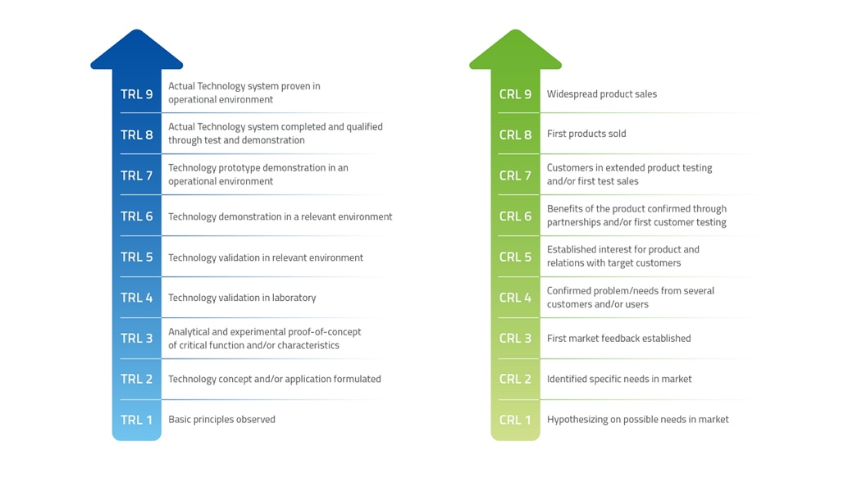

Figure 2. Customers and technology readiness.

