SpectriS-Dot

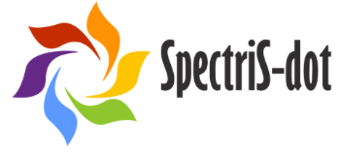
Logo
✓ | Theme: Substitution of critical and toxic materials in products and for optimised performance
✓ | Solution: production of full-color spectrum light emitting, non-toxic and cost-efficient quantum dots
✓ | Market: Display-, Lighting-, Medical- and Security markets
✓ | Status: Start-Up
✓ | CLC West

Description
SpectriS-Dot has developed light emitting quantum dots (QDs) covering the full color spectrum, based on an abundant and non-toxic material silicon (Si). Compared to competitive solutions, these C:Si QDs provide similar optical qualities, improved stability, ease of preparation and increased functionality. These C:Si QDs have the potential to replace all currently employed toxic and/or scarce materials used in LEDs and displays, as well as in a variety of other applications.

Market Need
The market of light emitting materials is in need of energy-efficient, cost-efficient and non-polluting materials. This market demand is fast growing and is currently a multibillion EUR industry. However, currently employed QDs are based on toxic and/or scarce elements (Cd, In, Se, Pb, As, etc.) and there is growing legislation to ban out this type of QDs (e.g. USA, NSF act of 2010). Current restrictive legislation on heavy metal use (Pb, Cd) and cost issues with scarce elements (In) only applies to the currently employed QD materials and can therefore be considered as stimulating legislation for SpectriS-Dot’s silicon based quantum dots (C:Si QDs).

Customers, mainly the large OEMs of displays, screens, LED etc., include companies such as: Sony, Samsung, LG, Philips, Osram, Alltop, 3M, DSM, AkzoNobel etc.
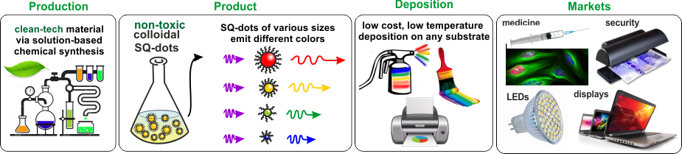
Figure - summary sketch of the main advantages of our material - clean technology, non-toxic product with full-color emission, low cost and large areas deposition possibilities and broad market range.

Benefits
Features | Benefits | Values
Physical Characteristics  & Environment | Cost-efficient and non-toxic quantum dots (pure silicon based) | Future proof – ability to comply with increase safety and environmental legalisation
Performances | Stability of the quantum dots | End products like TVs will have no ‘bleaching’ screens
Safety (human) production process | Non-toxicity | Cheaper labs / fabs and safety measurements in handling quantum dots

KIC Impact and Contribution (or Relevance to KIC community)
SpectriS-Dot is a spin-off of University of Amsterdam and works in close collaboration with the research department of the University of Twente, all non-KIC partners. However, the new developed C:Si quantum dot is relevant for the huge LED (lighting) and Display production market, product applications in virtually all KIC-core markets and thus potentially impactful and relevant for many KIC partners active in these markets and /or the value chain. For reasons of; substituting CRMs, increased product durability, cost reduction (resources, energy usage and EOL) and their potential impact (multibillion EUR market), SpectriS-Dot tics a lot of boxes when it comes to KICs focus areas, goals and KPIs.

SpectriS-Dot is not a spin-off of KIC-partners, nor a product of KICs knowledge triangle collaboration, but did benefit from it and is open for active involvement in KIC activities, durable relations with KIC partners (esp. R&D) and for (potential) KIC equity investments.

Contact | SpectriS-Dot  Wethouder Driessenstraat 21  1107XG, Amsterdam, The Netherlands  http://www.spectris-dot.com | Radboud van Kleef  Function CEO  Phone +31 6 10 32 62 46  Email vankleef@spectris-dot.com
EIT RM | CLC West | Beant Dijkstra  Function Business Developer  Phone +32468411835  Email beant.dijkstra@eitrawmaterials.eu

Additional information (not to be disclosed | for internal use only | will be deleted)
Project start 1 November 2017, end date 31 October 2018
Amount of funding: EUR 60,000

